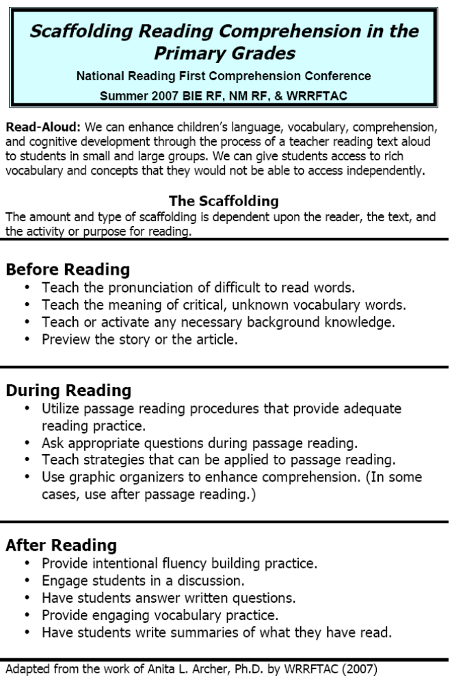
Anita Archer Video #1: Grade 2 Read Aloud: Wolf!

Record Effective Instructional Strategies Observed:
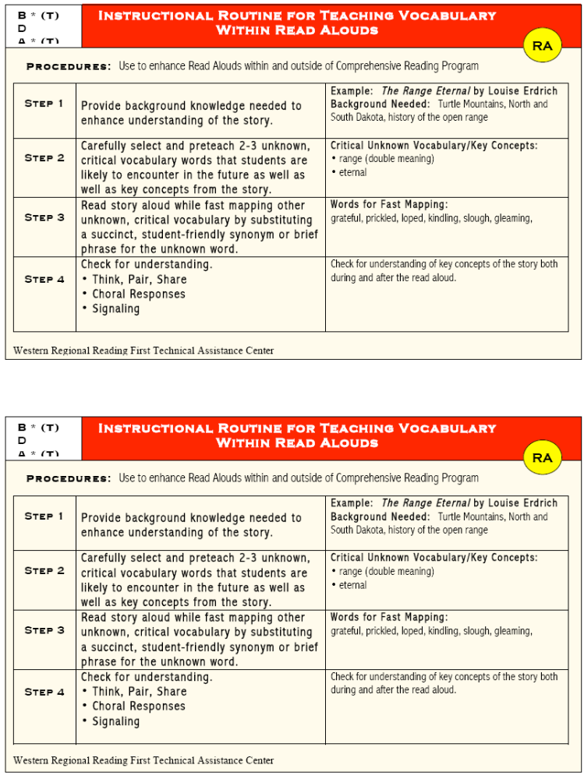
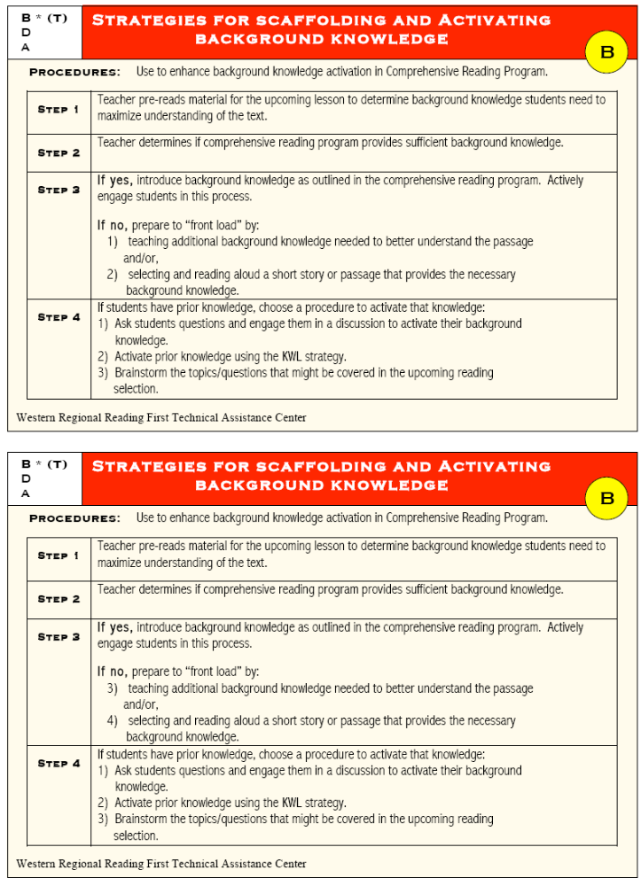
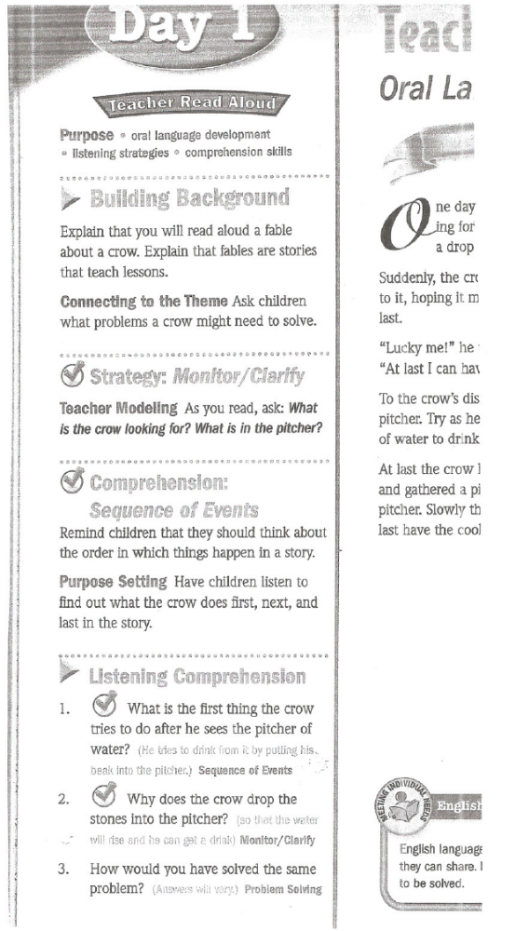
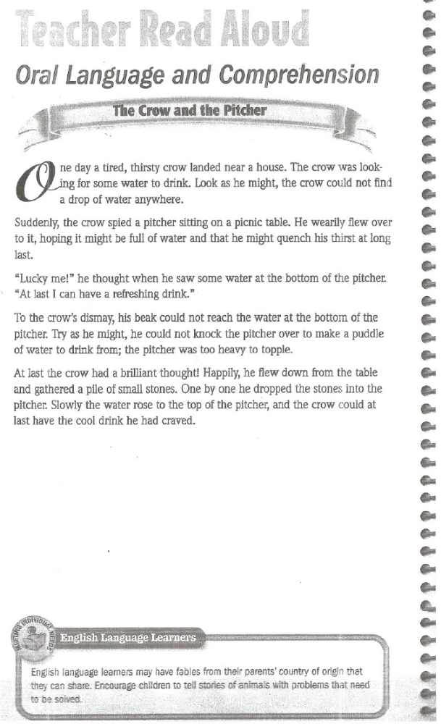

Anita Archer Video #2: Grade K Read Aloud: Honk!

Record active engagement strategies and other good instructional practices observed:

What words does Anita “fast-map”?

Story Map 1

Beginning

Middle

End

Story Map 2

Setting:
Where:

When:

Characters:

Problem:

 | Beginning: |  | Middle: |  | End:

Solution:

